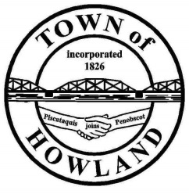
A G E N D A

HOWLAND BOARD OF SELECTPERSON’S MEETING
Selectpersons: April 20, 2021 at 6:00 PM
Watch the meeting live on our Facebook page
- Call to Order
- Pledge of Allegiance (Please Stand)
- Accept the minutes from the April 5, 2021 selectperson’s meeting.
- Public Comments/Questions – 3-5 Minute Limit per Commentator.
- Any changes to the Agenda
- Old Business:
- New Business:
- Discussion on updated fire department billing policy
- Motion to approve/not approve the updated fire department billing policy
- Discussion on LD920
- Manager’s Report
  - Update on new Fire/EMS/Municipal building progress (Dwight, David)
  - I would like to ask a member of the board to assist us in the new deduct water meter trial before we start this process with the general public. A meter will be available immediately for use and to make sure to connect the meter to an outside spigot that is used most often. At the next scheduled water meter reading in June you will be required to provide us the reading on the deduct meter for billing.
- Fire/EMS update (Chief McNally)
- Events update (Pricilla or Tami) Please give a brief update on events being planning
- Future Agenda Items.
- Adjourn

