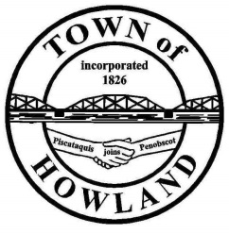
A G E N D A

HOWLAND BOARD OF SELECTPERSON’S MEETING
Selectpersons: May 3, 2021 at 6:00 PM
Watch the meeting live on our Facebook page
- Call to Order
- Pledge of Allegiance (Please Stand)
- Accept the minutes from the April 20, 2021 selectperson’s meeting.
- Public Comments/Questions – 3-5 Minute Limit per Commentator.
- Any changes to the Agenda
- Old Business:
- New Business:
- Discussion on cemetery fence/tree
- Discussion on allowing weddings to be performed at the Old Tannery Park.
- Discussion on equipment acquisition.
- Manager’s Report
  - Update on new Fire/EMS/Municipal building progress (Dwight, David)
- Fire/EMS update (Chief McNally)
- Planning Board Update (David/Josh)
- Events update (Pricilla/Tami) Please give a brief recap on the Daffodil event.
- Future Agenda Items.
- Adjourn

