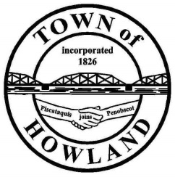
A G E N D A

HOWLAND BOARD OF SELECTPERSON’S MEETING
Selectpersons: May 17, 2021 at 6:00 PM
Watch the meeting live on our Facebook page
- Call to Order
- Pledge of Allegiance (Please Stand)
- Accept the minutes from the May 3, 2021 selectperson’s meeting.
- Public Comments/Questions – 3-5 Minute Limit per Commentator.
- Any changes to the Agenda
- Old Business: NA
- New Business:
- Discussion 2021 scholarships
- Discussion on the draft wedding policy.
- Manager’s Report
  - Update on new Fire/EMS/Municipal building progress (Dwight, David)
  - We were able to negotiate the price of the Cat backhoe/loader down to $77K saving an additional $2,000
  - Property maintenance ordinance update (where we are at)
  - Personal Property tax uncollectable accounts
- Fire/EMS update (Chief McNally) hiring
- Planning Board Update (David/Josh) (CNL updated plan for larger unit)
- Future Agenda Items.
- Adjourn

