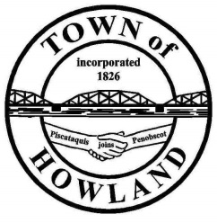
A G E N D A

HOWLAND BOARD OF SELECTPERSON’S MEETING
Selectpersons: June 7, 2021 at 6:00 PM
Watch the meeting live on our Facebook page
- Call to Order
- Pledge of Allegiance (Please Stand)
- Accept the minutes from the May 17, 2021 selectperson’s meeting.
- Public Comments/Questions – 3-5 Minute Limit per Commentator.
- Any changes to the Agenda
- Old Business:
  - Park/wedding policy
  - The Board approval of the EDC recommendation of the welcome to Howland statement.
  - Cemetery fence/gate/tree
- New Business:
  - Planning Board Appointment Pricilla Clark
- Manager’s Report
  - Update on status of the public works garage project
  - Insurance update.
  - The town office will be closing at 12PM June 30th for the closing of the fiscal books.
  - Town managers concern regarding ransomware and municipal files backup
  - Peddlers/venders using town property
  - Tree removal on River Road
- Fire/EMS update (Chief McNally)
- Planning Board Update
- Executive session – Title 1, M.R.S.A, §405 (6) (D) Town Manager’s evaluation
- Future Agenda Items.
- Adjourn

