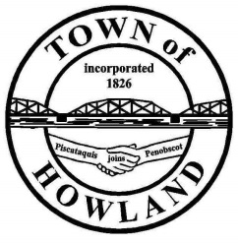
A G E N D A

HOWLAND BOARD OF SELECTPERSON’S MEETING
Selectpersons Workshop at Cemetery: June 21, 2021 at 5:30-5:50 PM
Selectpersons Meeting June 21, 2021 at 6:00PM
Watch the meeting live on our Facebook page
- Call to Order
- Pledge of Allegiance (Please Stand)
- Accept the minutes from the June 7, 2021 selectperson’s meeting.
- Public Comments/Questions – 3-5 Minute Limit per Commentator.
- Any changes to the Agenda
- Old Business:
  - Cemetery fence/gate/tree discussion
  - Updated wedding policy (security deposit required)
  - Revised welcome to Howland statement
- New Business:
  - Sewer abatement request account #384 for $742.50
  - Discussion on EV charging station
- Manager’s Report
  - 2020 annual solid waste report
- Fire/EMS update (Chief McNally)
- Planning Board Update NA
- Executive session – Title 1, M.R.S §405 (6) (D) Town Manager Contract negotiations
- Executive session – Title 1, M.R.S. §405(6) (D) Fire Dept.
- Future Agenda Items.
- Tami Colbath
- Adjourn

