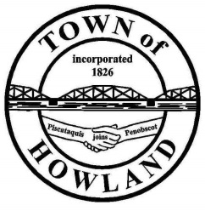
A G E N D A

HOWLAND BOARD OF SELECTPERSON’S MEETING
Public Hearing July 6, 2021 at 6:00PM
Selectpersons Meeting July 6, 2021 immediately following the public hearing
- Open public hearing to hear oral and written comments on the renewal of a malt and vinous liquor license for J&M 95er LLC.
PH Open________________ PH Close___________________
Motion:
Selectpersons Meeting
- Call to Order
- Pledge of Allegiance (Please Stand)
- Election of Officer (Board Chair)
- Election of Officer (Board Vice-Chair)
- Accept the Roberts Rules of Order for all meetings and procedures for FY22
- Accept the minutes from the June 21, 2021 selectperson’s meeting.
- Public Comments/Questions – 3-5 Minute Limit per Commentator.
- Any changes to the Agenda
- Cemetery and veterans park update.
- Old Business: NA
- New Business:
  - Rescheduling the 7/19/2021 BOS meeting to 7/26/2021.
  - To allow the American Legion, Lee Graham Post #97 to be able to use the town owned lot on Front Street for off road parking.
  - Annual appointments Tax collector David Lloyd, Treasurer David Lloyd, Planning Board Gail Garron and Board of appeals Chris Thompson.
- Manager’s Report
  - PS #1 generator update
  - New building update (Dwight)
- Fire/EMS update (Chief McNally)
- Planning Board Update NA
- Future Agenda Items.
- Adjourn

