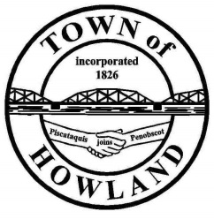
A G E N D A

HOWLAND BOARD OF SELECTPERSON’S MEETING
Selectpersons Meeting July 26, 2021
- Call to Order
- Pledge of Allegiance (Please Stand)
- Accept the minutes from the June 21, 2021 selectperson’s meeting.
- Public Comments/Questions – 3-5 Minute Limit per Commentator.
- Any changes to the Agenda
- Old Business:
  - Cemetery policy (Draft)
  - Veterans Memorial fencing & Lighting update.
- New Business:
  - Motion to Award the 2021 plow truck financing to Machias Saving Bank. 148,037 will be financed for 8 years at 2.35% with an annual payment $20,585.01.
  - Motion to award purchase a 2021 plow truck from Daigle & Houghton for a 2021 International in the amount not to exceed $167,150
  - Transfer Station trash bag discussion
- Manager’s Report
  - FEMA reimbursement for COVID19 related expenses update.
  - Cemetery concerns
- New building update (Dwight)
- Fire/EMS update (Chief McNally)
- Community Events update
- SAD 31 Update
- Future Agenda Items.
- Adjourn

