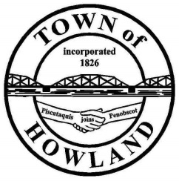
A G E N D A

HOWLAND BOARD OF SELECTPERSON’S MEETING
Selectpersons Meeting August 9, 2021 @ 6PM
- Call to Order
- Pledge of Allegiance (Please Stand)
- Accept the minutes from the July 26, 2021 selectperson’s meeting.
- Public Comments/Questions – 3-5 Minute Limit per Commentator.
- Any changes to the Agenda
- Old Business:
  - Veterans Memorial fencing update.
- New Business:
  - Motion to designate the following recreational areas as drug free zones
    - Terrio Street playground & recreational area
    - Penobscot Ave boat launce area
    - Water Street boat launce area
    - Veterans Memorial Park
NOTE: Designated areas have a 1,000 foot radius that carries a stricter penalty for violators. The town will be responsible to install proper signage in these areas.
  - Motion to schedule a public hearing for the purpose of discussing water/sewer rate increase.
NOTE: I would be looking at a Jan 1st start date if the new rates were approved by the Board (sewer) & (PUC for water rate).
- Sewer abatement request for account #437 in the amount of $105.
NOTE: Outside spigot corroded and leaked. (This is a formality as we now allow residents to utilize a meter so not to be charged for sewer usage fees for water used that doesn’t enter the sewer system.
- Manager’s Report
  - Pump Station #1 generator update (Insurance claim)
  - Ambulance rental while our unit in being repaired. (up to 45 days)
  - Tax commitment date is scheduled for 8/26-8/27 which will allow us to print and mail tax bills by the first week in Sept.
- New building update (Dwight)
- Fire/EMS update (Chief McNally)
- Future Agenda Items.
- Adjourn

