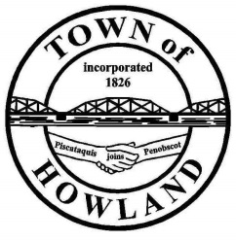
A G E N D A

HOWLAND BOARD OF SELECTPERSON’S MEETING
Selectpersons Meeting August 23, 2021 at 6PM
FACE COVERINGS ARE RECOMMENDED AS OF 8/23/2021
- Call to Order
- Pledge of Allegiance (Please Stand)
- Accept the minutes from the August 9, 2021 selectperson’s meeting.
- Public Comments/Questions – 3-5 Minute Limit per Commentator.
- Any changes to the Agenda
- Old Business:
  - Veterans Memorial fencing update.
- New Business:
  - Discussion: Electrical Inspection ordinance.
- Manager’s Report
  - Drug Free Zone update
  - Water Street Boat launch parking
  - Heating fuel bids will be awarded by the BOS in September
- New building update (Dwight)
- Fire/EMS update (Chief McNally)
- SAD 31 update
- EDC update: (P&T) Boat launch signage project
- Motion to proceed into executive session -Title 1, M.R.S. §405 (6) (D) Contract negotiations between the Town of Howland and Irelands Rubbish Services.
- Future Agenda Items.
- Adjourn

