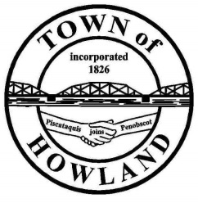
A G E N D A

HOWLAND BOARD OF SELECTPERSON’S MEETING
Selectpersons Meeting September 20, 2021 at 6PM
FACE COVERINGS ARE RECOMMENDED
- Call to Order
- Pledge of Allegiance (Please Stand)
- Accept the minutes from the September 7, 2021 selectperson’s meeting.
- Public Comments/Questions – 3-5 Minute Limit per Commentator.
- Property Tax discussion with Glenn Brawn
- Any changes to the Agenda
- Old Business: NA
- New Business:
  - Motion to accept the 2021 MMA General Assistance Ordinance and appendices A-H.
- Manager’s Report
  - Fireworks discussion
  - Mike Sereyko cemetery repair
- New building update (Dwight)
- Fire/EMS update (Chief McNally)
- Economic Development Committee update. (Priscilla)
- SAD31 update. (Priscilla)
- Future Agenda Items.
- Adjourn

