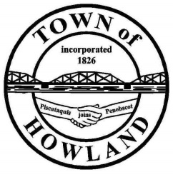
A G E N D A

HOWLAND BOARD OF SELECTPERSON’S MEETING
Selectpersons Meeting September 7, 2021 at 6PM
FACE COVERINGS ARE RECOMMENDED
- Call to Order
- Pledge of Allegiance (Please Stand)
- Accept the minutes from the August 23, 2021 selectperson’s meeting.
- Public Comments/Questions – 3-5 Minute Limit per Commentator.
- Any changes to the Agenda
- Old Business:
  - Discussion: Updated electrical inspection process.
- New Business:
  - Motion to accept the 2021 general assistance amended ordinance.
  - 2021-2022 heating fuel bid opening
  - Motion to award the 2021 heating fuel bid to
  - 1st public hearing for the proposed water/sewer rate increase is scheduled for 9/20 after the selectpersons meeting.
  - Merrill Brook crossing discussion
  - Fireworks concern
- Manager’s Report
- New building update (Dwight)
- Fire/EMS update (Chief McNally)
- Future Agenda Items.
- EDC Drawing for the butterfly project winner.
- Adjourn

