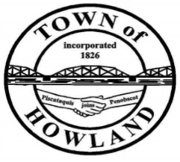
A G E N D A
HOWLAND BOARD OF SELECTPERSON’S MEETING
Selectpersons Meeting November 1, 2021 at 6PM
FACE COVERINGS ARE REQUIRD
- Call to Order for Nov 1st 2021 at 6PM
- Pledge of Allegiance (Please Stand)
- Accept the minutes from the October 18, 2021 selectperson’s meeting.
- Public Comments/Questions – 3-5 Minute Limit per Commentator.
- Any changes to the Agenda
- Old Business: NA
  - We have requested additional patrols for several areas around town after hearing concerns from residents at the last SB meeting regarding speeding. We will also be replacing signage in this area.
  - Versant has been contacted but is currently waiting for us to have our flood lights removed prior to installing new lights at the playground.
- New Business:
  - Motion to approve a public hearing scheduled for November 14, 2021 at 4PM for the purpose of water/sewer rates.
  - Motion to approve $288 ad in the paper talks magazine (we will receive 45 copies)
  - Donation to Life Flight of Maine ($621)
- Manager’s Report
  - We have received a request from a Main Street tenant to use the vacant lot on First Street for parking this winter due to not having adequate parking at their building.
  - We have received the flashing speed zone sign. The public works is working on making this unit portable so it can be used in different areas.
- New building update (Dwight)
- Fire/EMS update (Chief McNally)
- EDC Update: Priscilla/Tami
- Future Agenda Items.
- Adjourn

