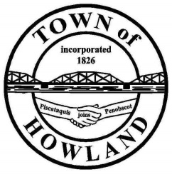
A G E N D A

HOWLAND BOARD OF SELECTPERSON’S MEETING
Selectpersons Meeting November 15, 2021 at 6PM
FACE COVERINGS ARE REQUIRD
- Call to Order
- Pledge of Allegiance (Please Stand)
- Accept the minutes from the November 1, 2021 selectperson’s meeting.
- Public Comments/Questions – 3-5 Minute Limit per Commentator.
- Any changes to the Agenda
- Old Business: NA
- New Business:
  - Plow truck bid opening.
  - Motion to award the 2004 sterling plow truck bid to ________________________ for $_________________________.
- Manager’s Report
  - The public works are back in the facility working as on Friday 11/12/21
  - By the end of the month the portable storage and office trailer are scheduled to be removed.
  - Versant Power has been notified that old flood lights at the ice rink area have been removed and they will be installing the new lights ASAP. Thank you to Dwight for spearheading the removal of those lighting units.
  - Wanted to let everyone know that the PW one ton is out of service. We were told that the unit will need a new injection pump, two injectors and possibly a new computer.
  - December 2nd coats for local kids (Mike Sereyko update)
- Fire/EMS update (Chief McNally)
- Motion to proceed into executive session -Title 1, M.R.S. §405 (6) (D) Contract negotiations between the Town of Howland and Plymouth Engineering.
- Future Agenda Items.
- Adjourn

