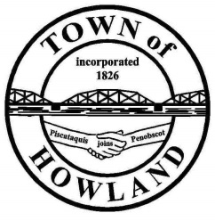
A G E N D A

HOWLAND BOARD OF SELECTPERSON’S MEETING
Selectpersons Meeting May 2, 2022 at 6PM

- Call to Order
- Pledge of Allegiance (Please Stand)
- Accept the minutes from the April 19, 2022, selectperson’s meeting.
- Any changes to the agenda
  - Public comment/questions (3-5 minutes)
- Old Business: NA
- New Business:
  - Eric Ericson discussion regarding abutting property lines.
  - Scholarships for two SAD31 students
- Manager’s Report
  - Passadumkeag request for licensing services. (Currently we receive $12-13 per registration which requires 5-20 min depending on if it is a reregistration or new)
  - Mowing Bid reminder
  - Buildings in disrepair update.
  - Property maintenance ordinance letters being sent out

- Fire/EMS update (Chief McNally)
- EDC/Events update
- SAD 31 update
- Future Agenda Items.
- Adjourn

