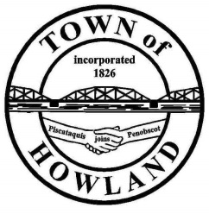
A G E N D A

HOWLAND BOARD OF SELECTPERSON’S MEETING
Selectpersons Meeting May 16, 2022 at 6PM

- Call to Order
- Pledge of Allegiance (Please Stand)
- Accept the minutes from the May 2, 2022, selectperson’s meeting.
- Any changes to the agenda
  - Public comment/questions (3-5 minutes)
- Old Business: NA
  - Eric Ericson email asking the Board to reconsider the surveying of the current town office property.
- New Business:
  - Discussion on wastewater valve pits repair plan.
    - Utilizing sewer reserves and ARPA funding to repair several of these pits
    - A. E Hodsdon is currently drafting bid specs for the valve pit repairs
  - Board discussion on installing video surveillance at the Old Tannery Park
  - Motion to appoint Mike Harris to the 2022 Appeals Board
  - Motion to appoint Tim King to the 2022 Appeals Board
- Manager’s Report
  - Board member Mike Sereyko has again donated his time to reset veterans’ stones in the Howland cemetery (Great job)
  - Mowing Bid reminder, Bid specs will be available at the town office on (5/16/22 BOS award bid on 6/21/22).
  - Discussion on moving the town office/library/fire/ems into the new building
- Fire/EMS update (Chief McNally)
- EDC/Events update
- SAD 31 update
- Future Agenda Items.
- Adjourn

