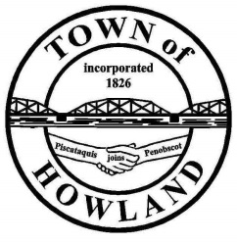
A G E N D A

HOWLAND BOARD OF SELECTPERSON’S MEETING
Selectpersons Meeting August 15, 2022 at 6PM
- Call the August 15, 2022 Town of Howland Selectpersons Meeting to Order
- Pledge of Allegiance (Please Stand)
- Motion to accept the minutes from the August 1, 2022, selectperson’s meeting.
- Any changes to the agenda
- Public comment/questions (3-5 minutes)
- Old Business: NA
- New Business:
  - Motion to appoint the following appointments for fiscal year 2022-2023
    - Town Manager as Tax Collector & Treasurer.
    - Planning Board of Appeals Chris Thompson
    - Planning Board Members Josh McNally, Nelson Kramer, John Neel and Chris Lord
  - Motion to approve sewer abatement request for Acct #354 in the amount of 222.75 for meter damage due to freezing.
- Manager’s Report
  - The bids for the sewer valve pit rehab were opened on 7/22 and four firms submitted bids. All four bids were significantly higher than expected. We are in the process of prioritizing what valves are critical to the operation of the lagoons and moving forward with a scaled down repair.
  - I have submitted the MMBB application for the financing on the new building.
  - We have requested additional funding for the emergency generator due to price increases and that request has been approved.
  - The towns of Passadumkeag and Seboeis will be performing registration services for their residents so there will not be service agreements with those towns for providing that service.
- Future Agenda Items.
- Adjourn

